COSTUME REQUIREMENTS – School Concert 2017
CHARACTER | COSTUME REQUIREMENTS FROM HOME – The following costumes details and pictures are examples and can vary slightly given the character is still shown. At this stage please locate, buy or borrow a costume of your child’s choice and have it ready for the concert on the week commencing Monday the 4th of December. Please note the dress rehearsal will occur in this week and it is crucial that your child has their costume ready before concert night. Concert night is on the 7th of December starting at 6pm.
Costume 1 | Red shirt  White flowy dress  Matching shoes or sandals
Costume 2 | A “Maui” costume from the Movie “Moana”  Feel free to make your own!
Costume 3 | Hawaiian style shirt – go for bright colours :)  Blue denim jeans  Matching black or white shoes

2
1
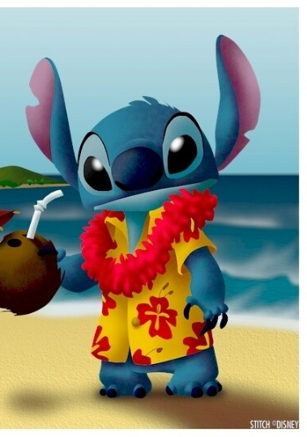
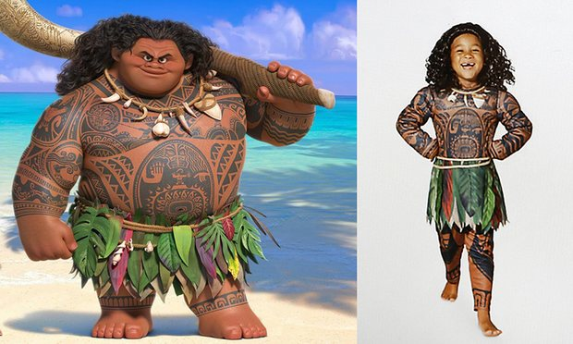
3

