COSTUME REQUIREMENTS – School Concert 2017
CHARACTER | COSTUME REQUIREMENTS FROM HOME – The following costumes details and pictures are examples and can vary slightly given the character is still shown. At this stage please locate, buy or borrow a costume of your child’s choice and have it ready for the concert on the week commencing Monday the 4th of December. Please note the dress rehearsal will occur in this week and it is crucial that your child has their costume ready before concert night. Concert night is on the 7th of December starting at 6pm.
Costume 1 | Black jacket  Green shirt  Blue denim jeans  Black or white shoes
Costume 2 and 3 | Any smart looking suit will look fantastic  Black shoes  Black Socks  A wacky colour tie or bow tie will also look flash!

1
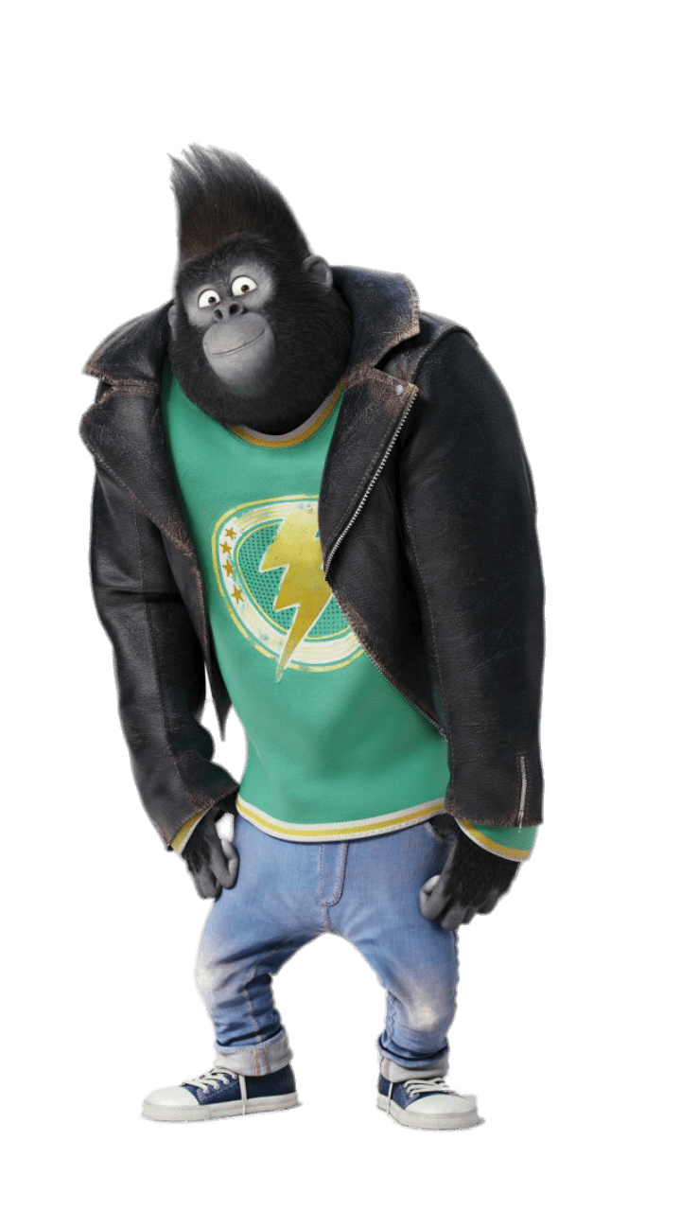
3
2

